**Feature Report**

**Computer Graphics & Animation**

By

**Al-Hassan Mohammad (w16020122), Efstathios Efstathiou (w15029887), Alexandros Dimitriadis (w15017967), Lida Ketsbaia (w16023235)**

KF6018

Faculty of Computing and Engineering, Northumbria University, Newcastle Upon Tyne, UK

2018-2019

Contents

Basic Rendering Elements 3

Motion Analysis 5

Feedback to The User 5

Advanced Use of the Motion Sensing Device 6

Student’s Proposed Features 8

# Basic Rendering Elements

* Skybox

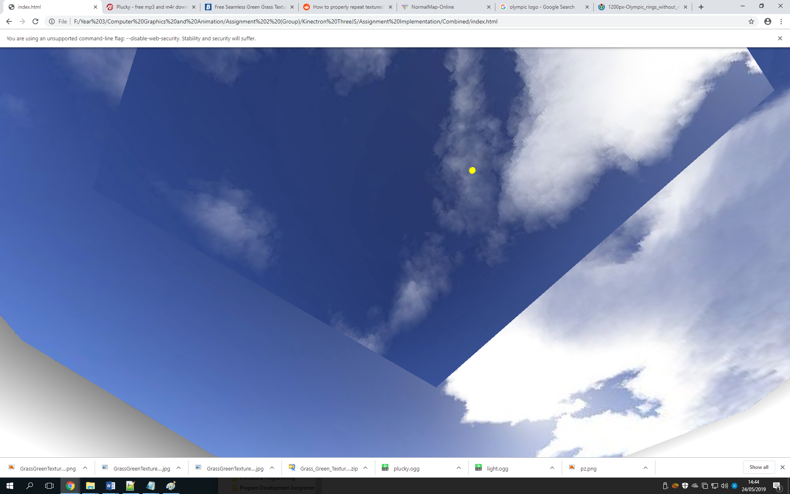

In the environment there is a skybox showing a cloudy blue sky which adds more brightness to the scene and makes it more immersive.

* Stadium

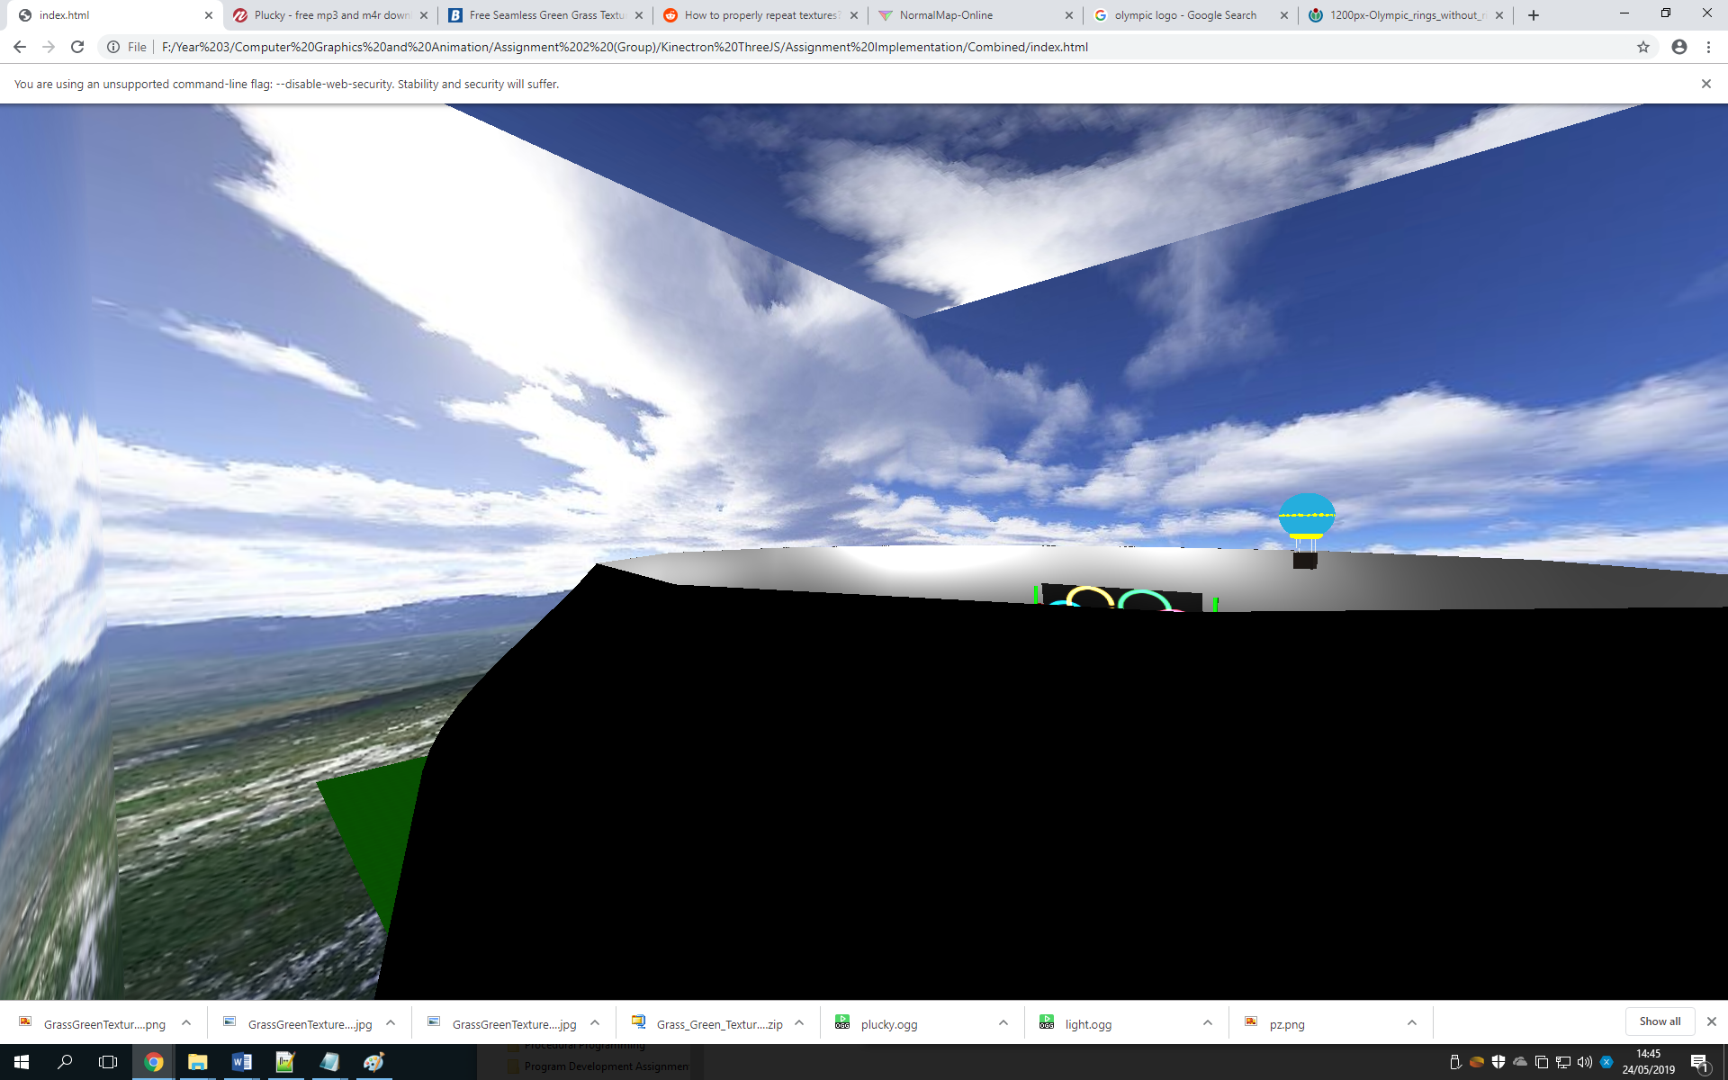

The stadium is made up of a Lathe Geometry which has been scaled up and positioned to encompass all the other environment objects in the scene.

* Lighting

In the scene there are 3 Point Lights floating in the stadium to make a bright scene which showcases all of the environment, there is also an ambient light to light up the edges of the scene.

* Textures

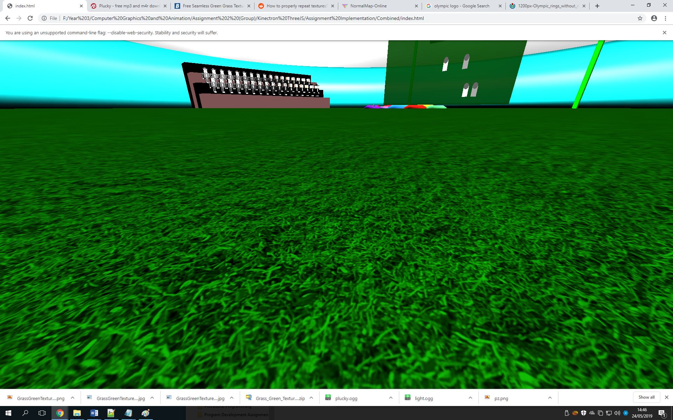

There is a grass texture on the ground with a normal map applied that was generated via <https://cpetry.github.io/NormalMap-Online/>, this texture gives a more realistic effect to the grass as it affects the way light hits it.

* Materials

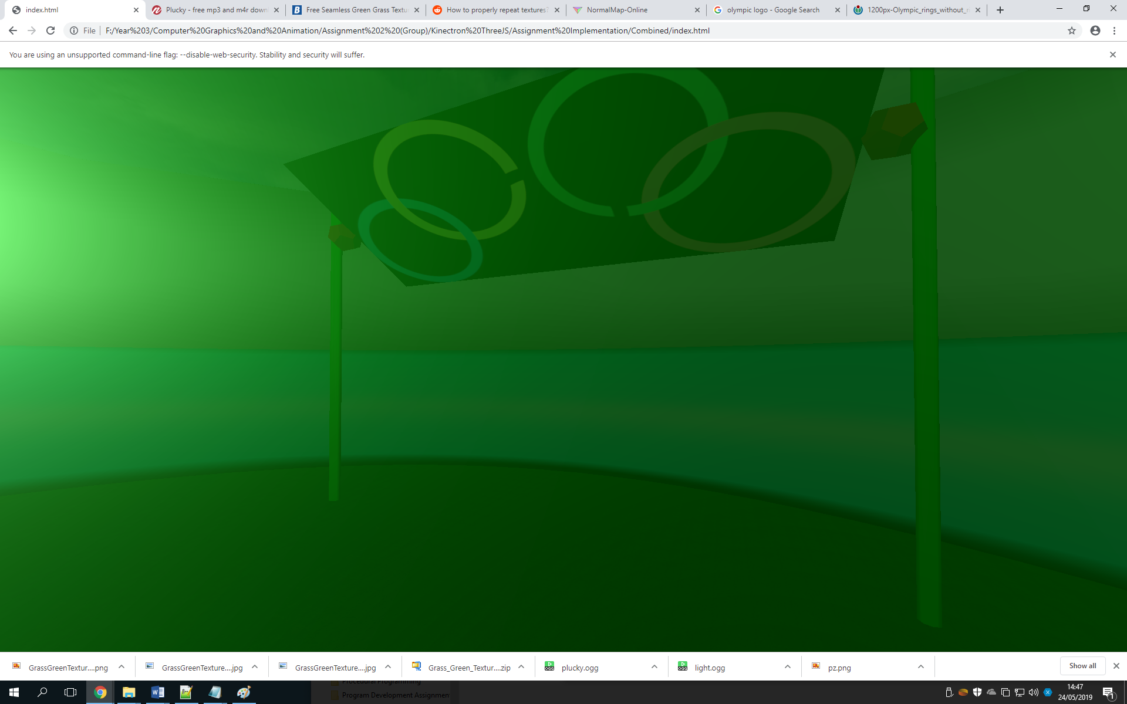

This is one example of a transparent material being used in the scene which allows the user to see the rest of the environment being occluded by the target mini-game.

# Motion Analysis

* List of Gestures used:
* Arms Spread
  + This gesture was created by getting the distance between the right hand and left hand positions in 3D space using Euler angles and then checking if the distance between the two Kinect joints exceeds a certain value to trigger the crowd waving.
* Arms above Hips
* This gesture was created by getting the distance between the right hand and right hip and also the left hand and left hip. This is then used in conjunction with the next gesture mentioned to trigger the firing of the weapon.
* Distance between left foot and right foot
  + This gesture is a simple check in distance between the left foot and right food in 3D space using the Kinect v2 joints and is used with the ‘Arms above Hips gesture to trigger the weapons firing.
* Filtering the right hand and left hand positions for smoother weapon firing
* To improve the accuracy of the shooting mini-game the right hand and left hand positions are filtered using a linear filter with 6 previous samples to smooth out the current position.

# Feedback to The User

The code for this project in the myScript.js shows feedback using the targets on the wall. When a collision is detected between the bullet and each individual target the targets will turn red and stop rotating to indicate they have been hit.

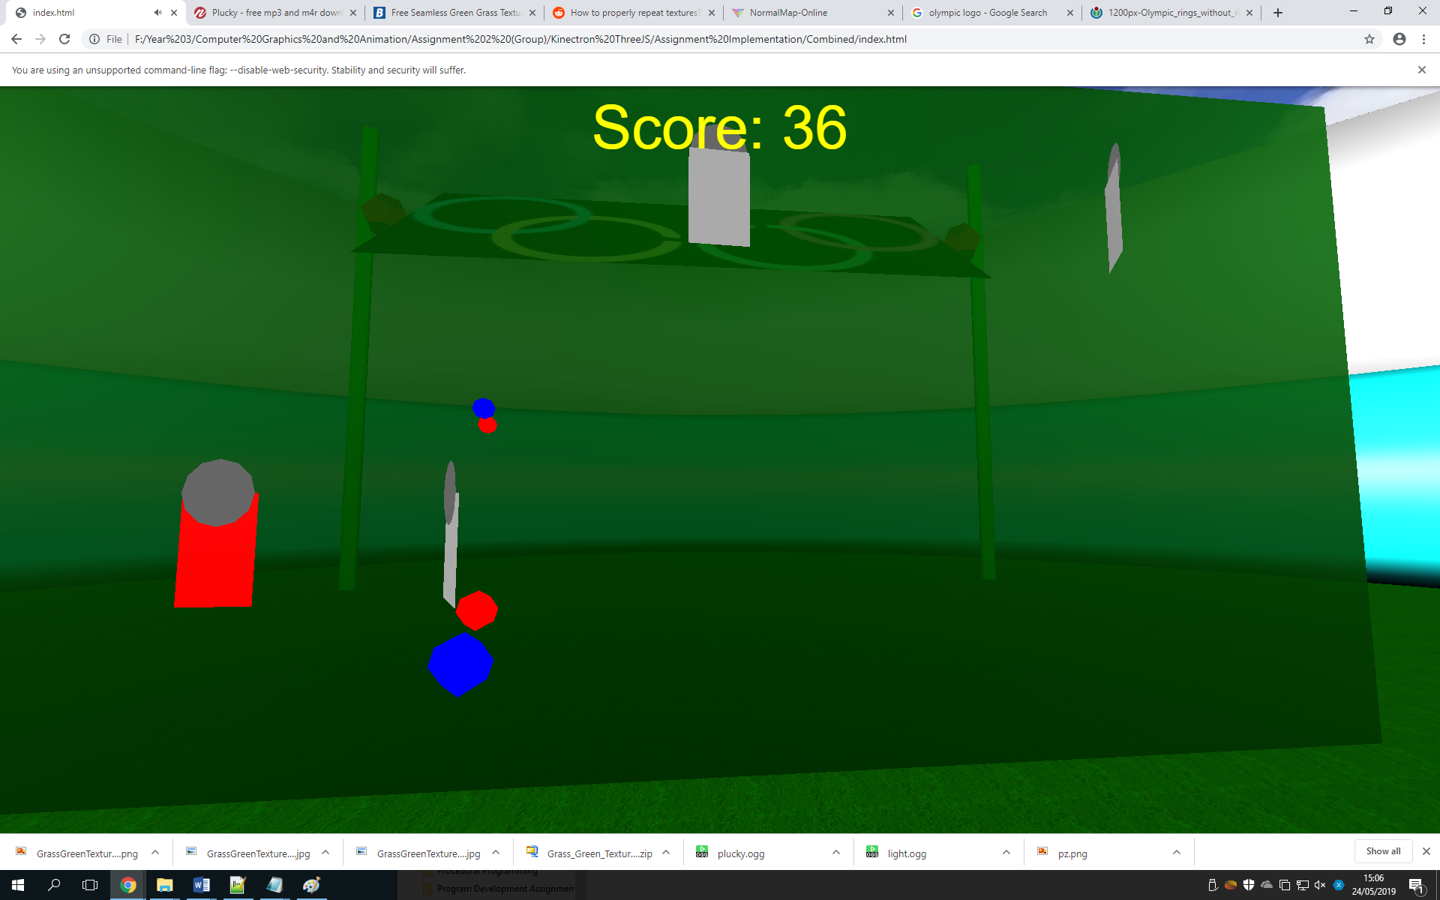

Another way which feedback is shown is via the sounds being played when the gun is fired and the target is hit, these sounds are individually different from each other to distinguish clear feedback when shooting and aiming at a target.

The Holes mini-game shows that when a ball falls into the centre after being kicked, the torus which collides with the ball will become a brighter colour to indicate visual feedback to the user.

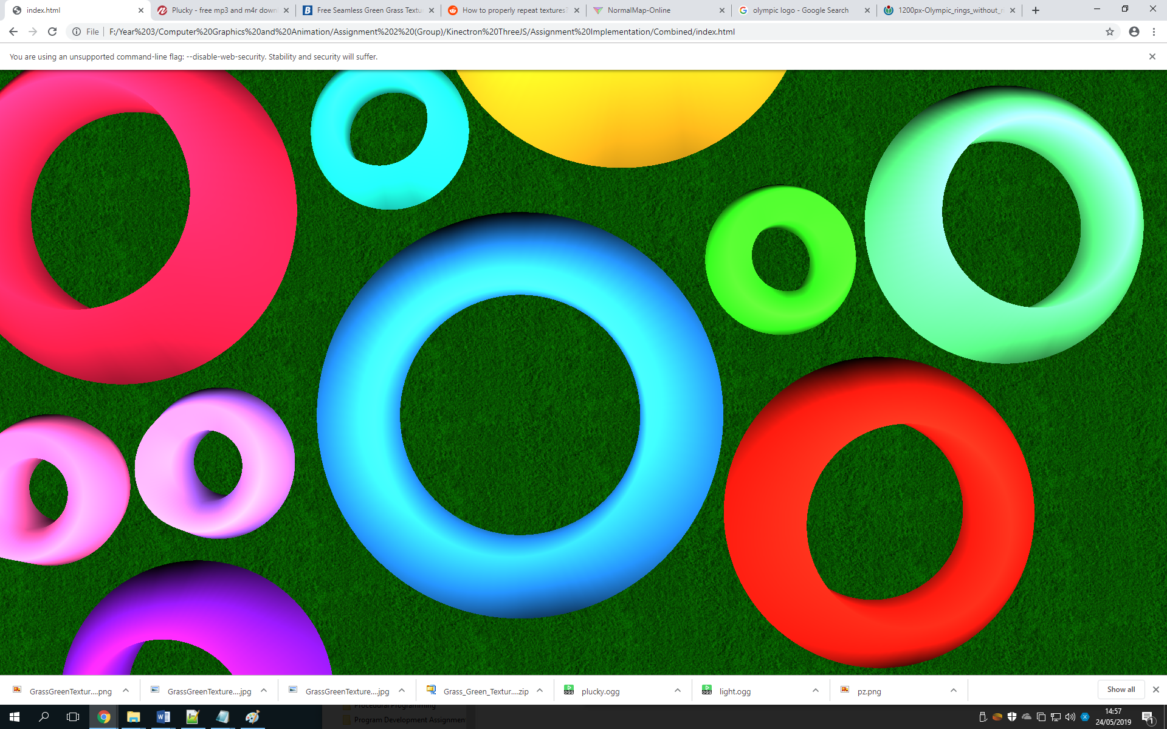

# Advanced Use of the Motion Sensing Device

* Using the Kinect Orientation data for live quaternions
* The Kinect v2 comes with orientation data for each joint which can be assigned to a quaternion, in this code the quaternion has been used to update the live orientation of the weapons. To avoid weapons on each hand facing in opposite directions a compromise was made where the quaternion for the right hand was also used for the left hand. This means that aiming in the shooting mini-game requires the use of the right hand only however the left hand position will still determine the starting position of the bullets from the left hand.
* The Kinect orientation data is also used to create a first person camera view via a quaternion, the camera position has an offset on the Z axis to feel less claustrophobic and more welcoming to the user. Rotating the shoulders from the user will cause the camera orientation to follow giving a true first person perspective in our environment.

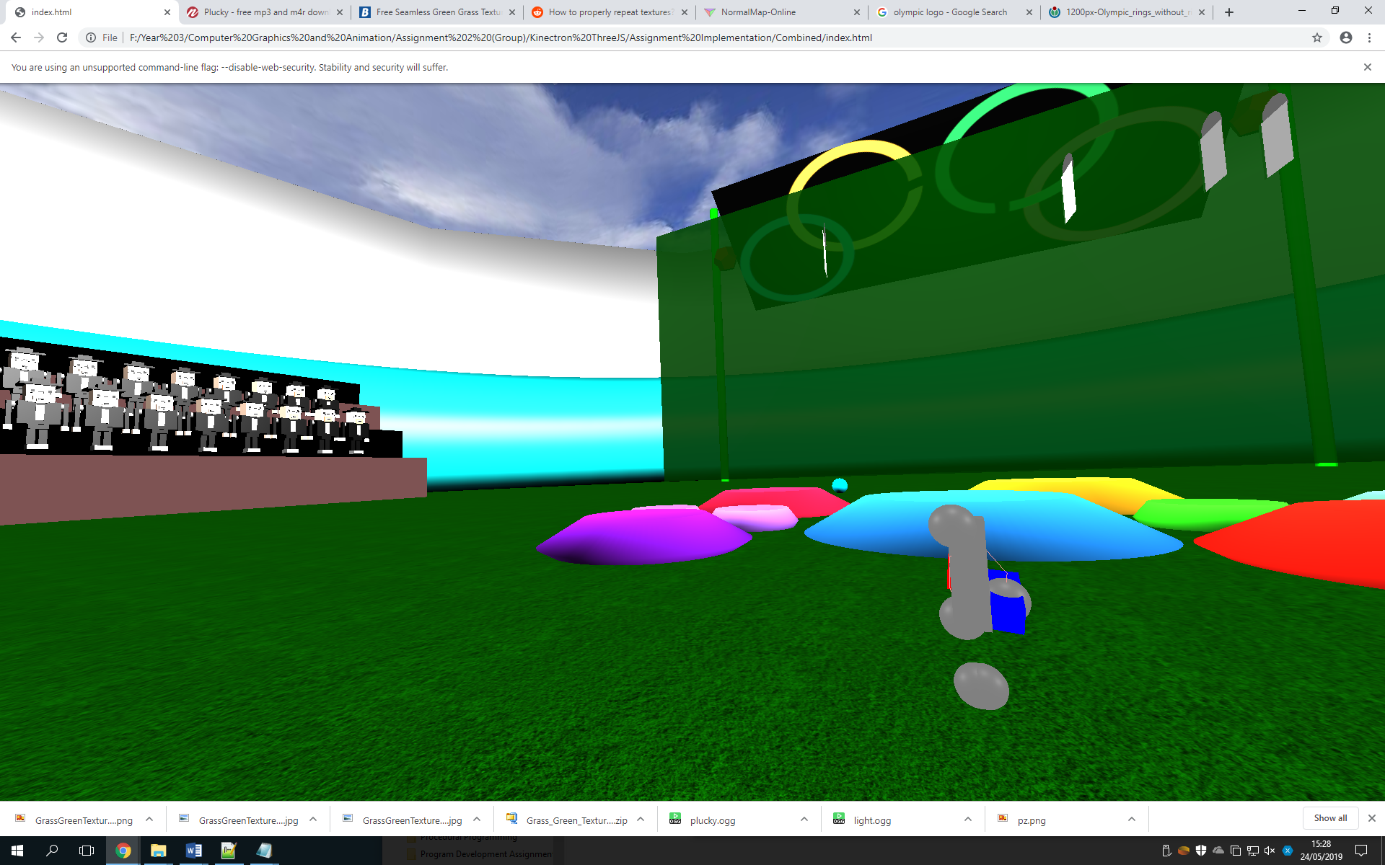

# Student’s Proposed Features

* Hassan Mohammad (w16020122)
* Firing mechanism of bullets and guns along local z axis

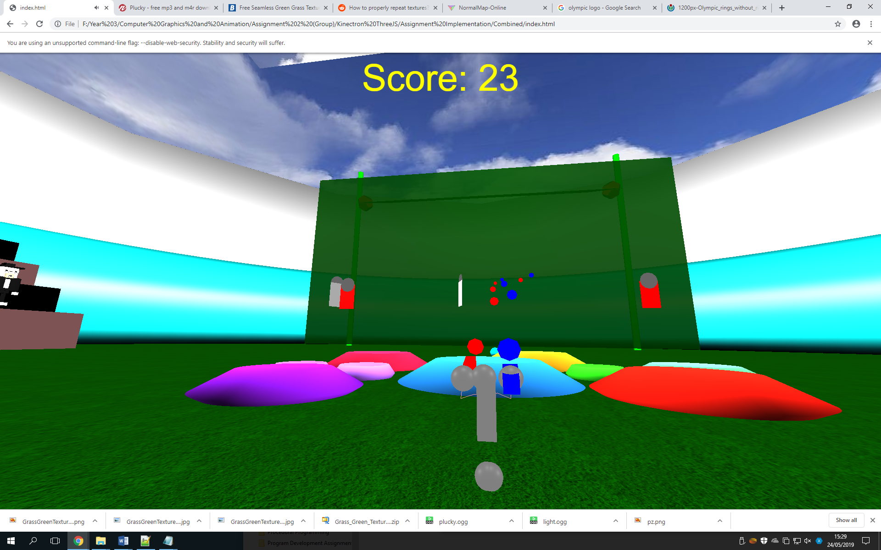

The first proposed feature is the firing mechanism of the guns along the local Z axis, when the fire signal is recognised the bullets are created and translated in the animate function where they are destroyed after a certain distance for optimization.

* Olympic Billboard sign rotating

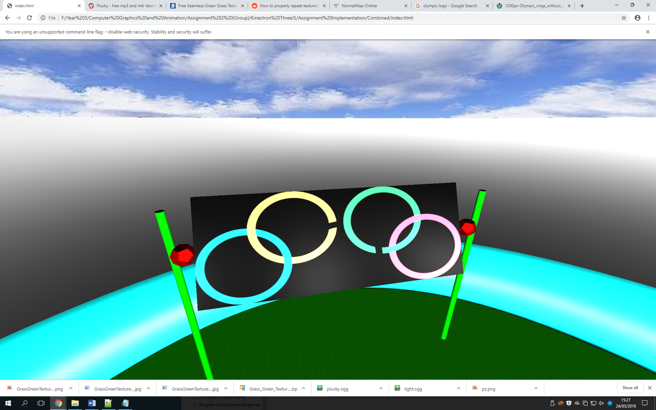

This proposed feature is using a texture mapped onto the billboard sign (plane) which is rotating steadily in the animate function, this is to help immerse the user in the Olympic and athletic festival theme being held inside the stadium.

* Scoring system using css overlay technique

This scoring system uses the ‘absolute positioning’ inside the CSS file to make sure the score is updated and overlaid on the whole environment, the score is updated via the document.write function in the animate function of the myScript.js file.

* Alexandros
* Created the crowds outline using various geometries that were combined together using parent chid relationships. Furthermore,
* Added a sound file when the crowd’s hands rose.
* Efstathios
* Created the two hot air balloons that can be seen floating. It was created using different geometries combined together with parent child relationships.
* Adjusted the mass on the feet to make sure the cannon is working
* I tried to make an array of falling spheres during the Canon implementation